Computer Language Diagrams

Method Definition Assignment in a Diagram
About the notation of assignment in general, see the article Assignment in a Diagram.

The principle of method definition assignment is explained in the article Method Definition Assignment. This article demonstrates the expression of it in a diagram.

To distinguish method definition assignment from other types of assignment such as value assignment, method definition assignment gets a special symbol:



This symbol is the identifier for object assignment.
It is an equals sign with an d in it, which stands for definition.

As such, a value assignment in a diagram looks like this:

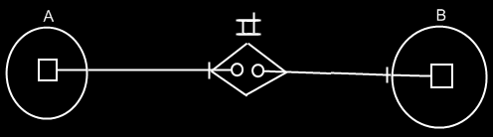

See also: Assignment in a Diagram, Method Definition Assignment

Author & Copyright: Jan-Joost van Zon Date: May 24, 2008 – May 24, 2008 Location: Oosterhout, The Netherlands Status: Finished

